Software Requirements Specification

for

Machine Learning based Stream Gauge

Version 3.0 approved

Prepared by Timothy Harrelson and Jeremy Swartwood

Capstone Project, UAA

02/01/2018

Table of Contents

Table of Contents ii

Revision History ii

1. Introduction 1

1.1 Purpose 1

1.2 Intended Audience and Reading Suggestions 1

1.3 Product Scope 1

1.4 References 1

2. Overall Description 1

2.1 Product Perspective 1

2.2 Product Functions 2

2.3 User Classes and Characteristics 2

2.4 Operating Environment 2

2.5 Design and Implementation Constraints 2

2.6 User Documentation 2

2.7 Assumptions and Dependencies 2

3. External Interface Requirements 3

3.1 User Interfaces 3

3.2 Software Interfaces 3

4. System Features 3

4.1 Image Processing 3

4.2 Image Classifying 4

5. Other Nonfunctional Requirements 5

5.1 Performance Requirements 5

5.2 Software Quality Attributes 5

6. Other Requirements 6

Appendix A: Glossary 6

Appendix B: Figures 6

Revision History

|  |  |  |  |
| --- | --- | --- | --- |
| **Name** | **Date** | **Reason For Changes** | **Version** |
| Timothy Harrelson Jeremy Swartwood | 02/01/2018 | Initial version | 1.0 |
| Timothy Harrelson Jeremy Swartwood | 02/25/2018 | Add changes from classmates during review.  Add Figures from Visio diagram. | 2.0 |
| Timothy Harrelson Jeremy Swartwood | 05/02/2018 | Adjust based on Gabor filter instead of HOG | 3.0 |

# Introduction

## Purpose

The purpose of this project is to evaluate an image of a body of water and categorize the pixels as either non-water or water using a machine learning classifier.

## Intended Audience and Reading Suggestions

The intended audience consists of two groups of people.

* The sponsor
* Development team

## Product Scope

Benefits

* This product will make the process of automatically determining the height of water cheaper by only requiring lower quality instruments.
* Setup will be easier with a reduction in required infrastructure like a bridge for the acoustic or visual gauge.
* No required survey of land prior to installation.

Objectives

* Identify the water pixels from an image.
* Gathering and preparing usable data for training and validation.

## References

# Overall Description

## Product Perspective

Currently the methods of identifying water height are expensive. In some instances this requires trained personal to interpret and gather data and survey land.

This will require much cheaper measuring instruments, less qualified personal, and low maintenance.

## Product Functions

* The users will enter an image into the product.
* The product will return a set of data identifying which pixels are water within the image.

## User Classes and Characteristics

The following groups will use the product:

* Researchers at NOAA and USGS
* Citizen science organizations

## Operating Environment

Operation will be done on a Windows OS, with limited or non-existent GPU.

## Design and Implementation Constraints

This product will use Python with OpenCV. Images will be any format accepted by OpenCV.

## User Documentation

A user manual or README will be created with the following information:

* The input format to the software.
* The commands to execute the software.
* The output format of the software.
* Details of how the software works will be described.

All code will be commented.

## Assumptions and Dependencies

Assumptions:

* Python3 installed on the computer with all required modules.
* Images must be a reasonable size.
* Images are assumed to be within a reasonable lighting condition.
* Images can be in any standard image format accepted by OpenCV.

Dependencies:

* Numpy
  + Used for complex mathematical computations on array in python.
* opencv-python
  + Used for image processing and common Computer Vision algorithms.

# External Interface Requirements

## User Interfaces

This product will utilize Command Line Interface. There will not be a GUI produced.

## Software Interfaces

Inputs:

Images in a standard image format are expected.

Outputs:

An output array of predictions is returned from an input image that is to be validated. Additionally an image with these predictions overlaid is displayed.

# System Features

## Image Processing

### Description and Priority

***NOTE:*** *This process is detailed in figures 1-7 in* *Appendix B.*

Analyzing images through the following process:

1. Using a **low pass filter** with *temporal differences* to generate a mask.
   1. Loop over each image in an input directory.
   2. **Average** the color intensities of each pixel with the surrounding pixels, a 20x20 region, to form a slightly blurred image. This reduces noise in the image and variation of a pixel from one (x,y) point to another.
   3. **Subtract** the color values of each temporally adjacent images to get the differences.
   4. **Average** the combined differences across all pairs of images.
   5. **Save** the final averaged image as the mask for the next step.
2. Use the mask to identify **Regions of Interest** (ROI). The mask indicates which type of feature is in the region.
   1. The output mask is run through K-means to find the closest color values, which creates four separate color values or Regions.
   2. Bands are created across the image by taking the highest color value for that row.
   3. The K-means mask and the bands are ANDED together to create the final mask. Overlapping regions are color value 0.
3. Use the OpenCV implementation of **Gabor Filters** algorithm to extract features from sub-sections of the ROI.
4. Use the features from the Gabor filters to train an Artificial Neural Network (ANN) in an unsupervised fashion to build the classifier. The trained ANN will be used to later classify new images.

### Stimulus/Response Sequences

A user will need to provide a batch of images to the Image Processor and start the process.

### Functional Requirements

REQ-1: Images must be all in a single folder, or they will not be processed.

REQ-2: Images that are different dimensions will be resized to the common image size.

REQ-3: Images must be taken sequentially in time without large gaps. The reason is to prevent drastic changes in the low pass temporal filter that could generate an inaccurate mask. A time frame of less than 2 hours between images, because of tide, is suggested.

REQ-4: Images must be named sequentially to match the order taken in time.

REQ-5: Images must be of the same site location and taken from the same camera position.

## Image Classifying

### Description and Priority

Classify sections of an input image (pixels) as either water or non-water.

### Stimulus/Response Sequences

User provides an image to the software and gives the command to start the process.

### Functional Requirements

REQ-1: If the host machine does not have software or modules installed an error message will be provided.

REQ-2: If an incorrect image format is provided, an error will be presented to the user.

REQ-3: If an image is too large or too small, an error will be presented.

REQ-4: When complete the software will produce a binary matrix the same size as the input image. Where each cell of the matrix signifying a pixel as water or not water.

# Other Nonfunctional Requirements

## Performance Requirements

User’s computers are assumed to be weak, meaning they won't require a high performance GPU or large Memory space.

## Software Quality Attributes

Accuracy of pixel classification.

# Other Requirements

# Appendix A: Glossary

Pixel Classification - A machine learning algorithm that determines if a pixel falls into a specific category.

ROI - Regions of Interest

ANN - Artificial Neural Network

# Appendix B: Figures



Figure – Overview for Image Processing

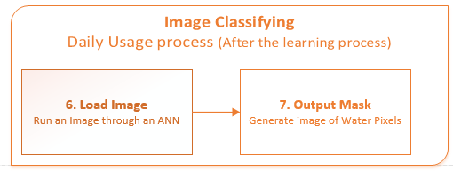

Figure – Overview for Image Classifying

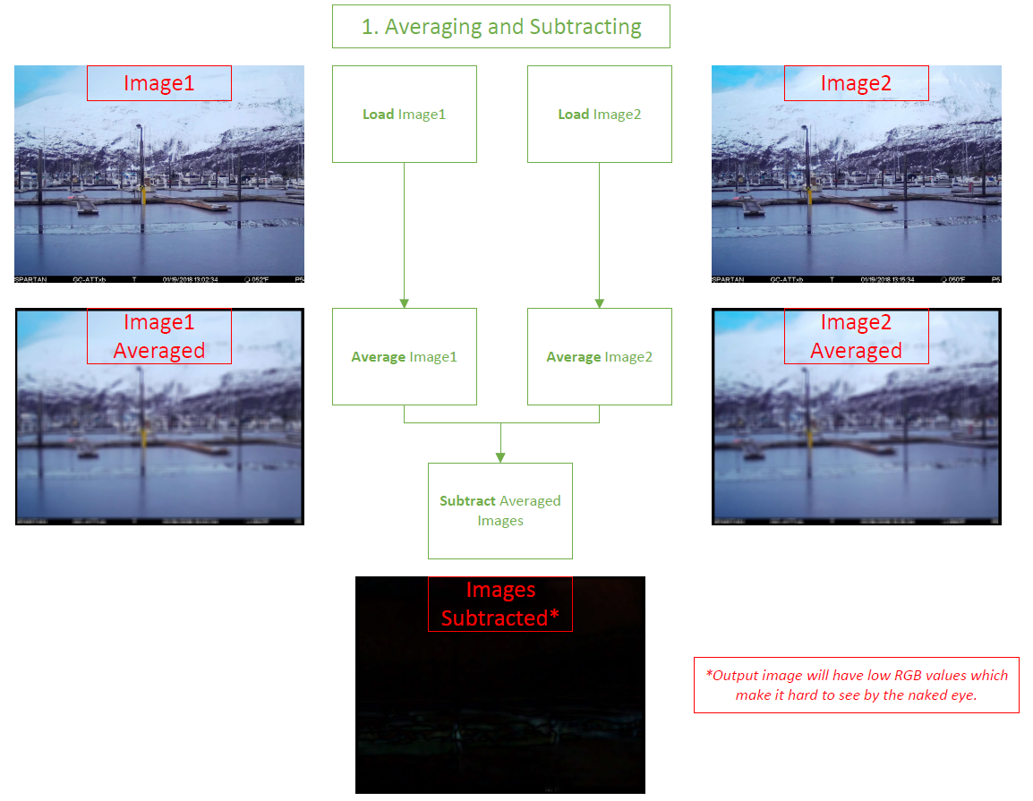

Figure – Process of applying low-pass filter for Image Processing



Figure – Details regarding the low-pass filter averaging.



Figure – Process of generating an output mask.

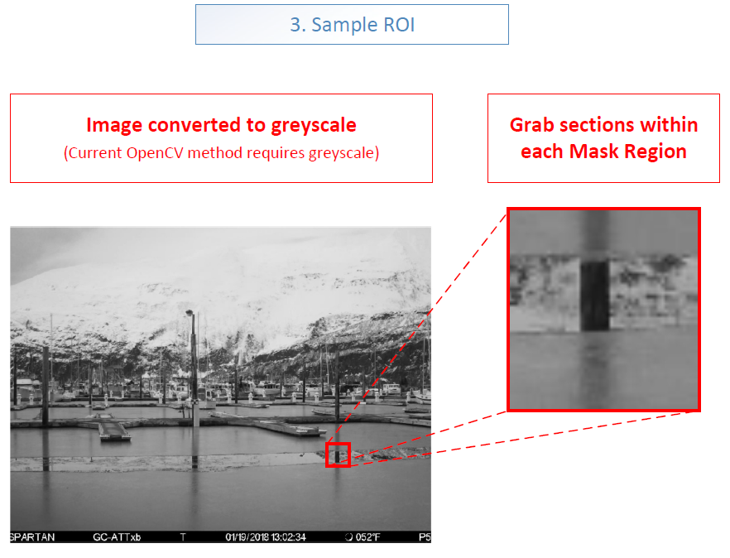

Figure – Process to sample sections of an image to generate HOGs for.



Figure – Example on how extracted ROI are turned into Gabor Filter feature vectors.